**CSF 2113 Lab 3.2 Iterations (while loops)**

1. **Using while loop in python**
2. What is the output of following code segment?

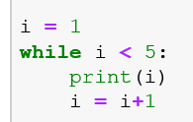

|  |
| --- |
|  |

1. What is the output of following code segment?

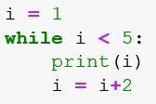

|  |
| --- |
|  |

1. What is the output of following code segment?

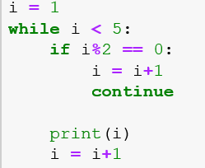

|  |
| --- |
|  |

1. What is the output of following code segment?

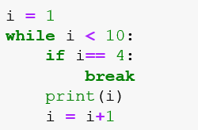

|  |
| --- |
|  |

1. **while loop statement in Python**
2. Write a program (using while loop) which take a range from the users and display all numbers in the range.

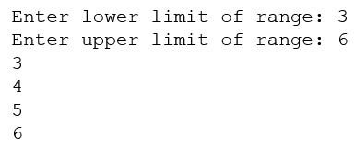

|  |
| --- |
| Paste you code and output here |

1. Write a program (using while loop) which take a range from the users and display all odd numbers in the range.

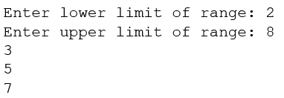

|  |
| --- |
| Paste you code and output here |

1. Write a program (using while loop) which take a range from the users and display all numbers which are multiple of 5 in the given range.

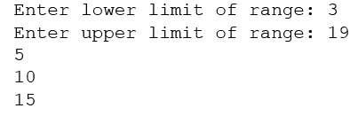

|  |
| --- |
| Paste you code and output here |

1. Write a program (using while loop) which take a range from the users and display sum of the numbers in the given range?

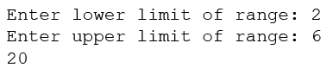

|  |
| --- |
| Paste you code and output here |

1. Write a program (using while loop) which take a range from the users and display sum of the all numbers which are multiple of 5 in the given range?

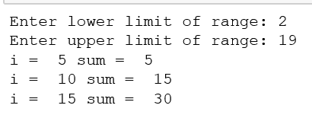

|  |
| --- |
| Paste you code and output here |

1. Write a program (using while loop) which generate integer random numbers between 0 and 10. Program should display the generated numbers and it should terminate when zero is generated as random number?

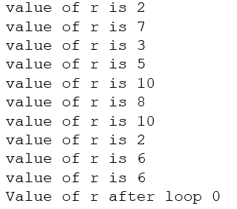

|  |
| --- |
| Paste you code and output here |

1. Write a program (using while loop) which takes a sequence of numbers from users. Program should stop taking input once user enter zero as input. Program should display the sum of all the numbers entered by user.

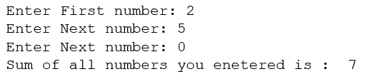

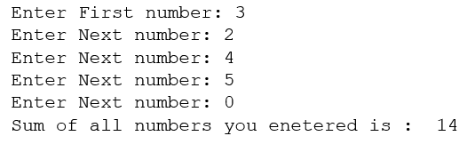

|  |
| --- |
| Paste you code and output here |

**End of Lab**